# Monitoring Tasks

1. **Enable cloudtrail monitoring and store the events in s3 and cloudwatch log events.**

* **Go to the aws console.**
* Then use a serach bar in cloud trial.
* Create a new work flow trail.
* Then choose new s3 bucket.
* Then disable the log file sse.
* Then use sns alert for trail role.
* Then create role.

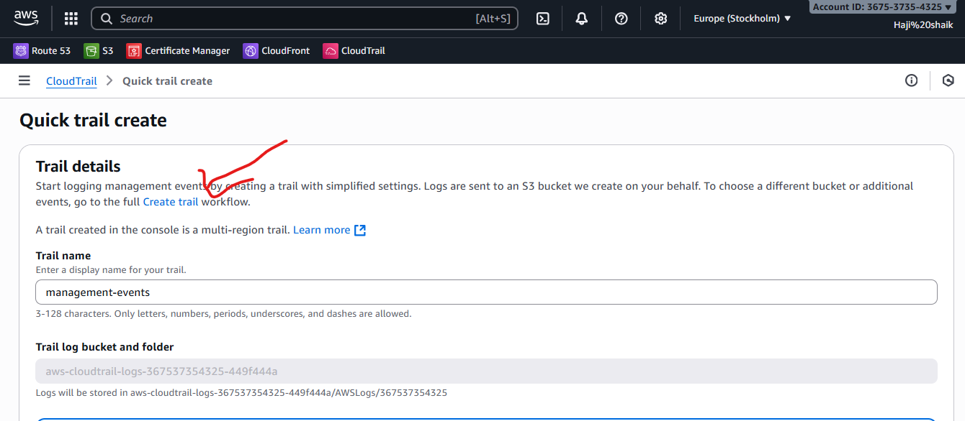

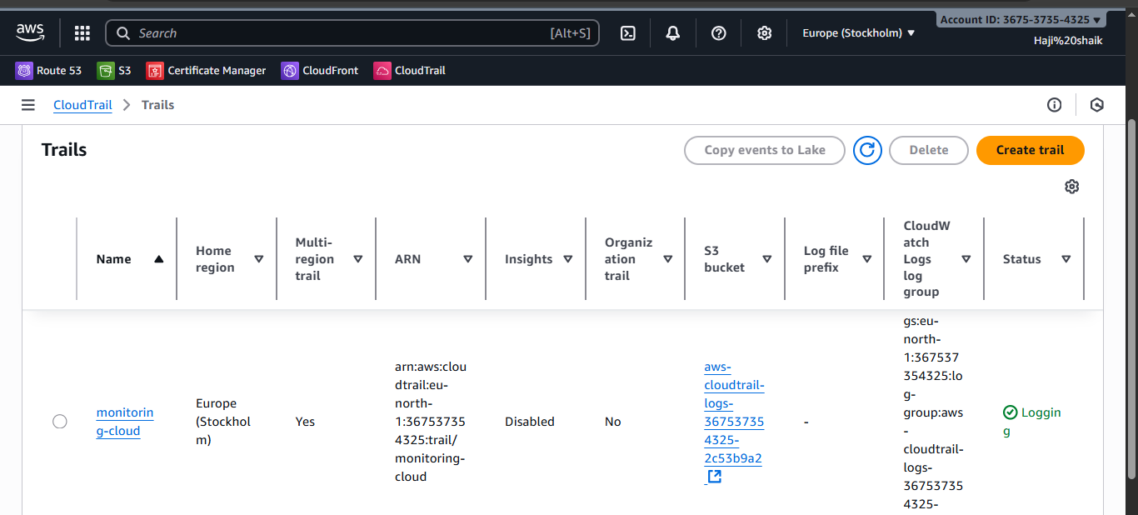

* Then go for **Cloud watch**.
* Then **Logs.**
* **Here the results are.**

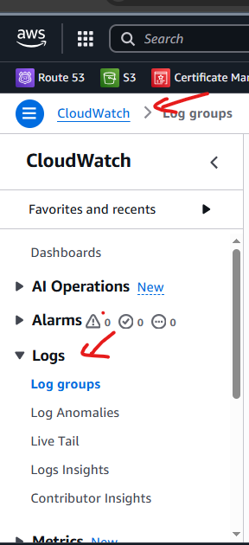

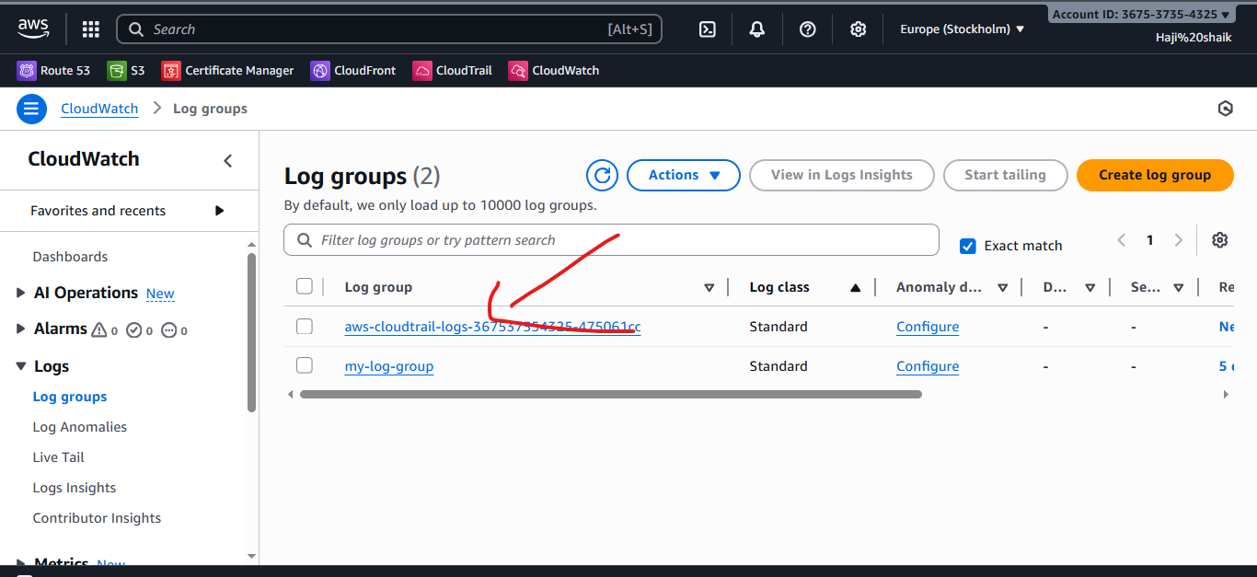

1. **Enable SNS for cloudtrial to send alert on email.**

* **Go to the AWS Console.**
* The use a search bar **SNS(Simple Notification Service)**
* Gave a topic name and create the topic.
* When topic is created then crete a subscription.
* In subscription choose email option.
* Then it will show uh pending.
* After that u get a confirmation messege to ur email.
* When uh accept that message then it will show uh confirmed.

**Step-1**

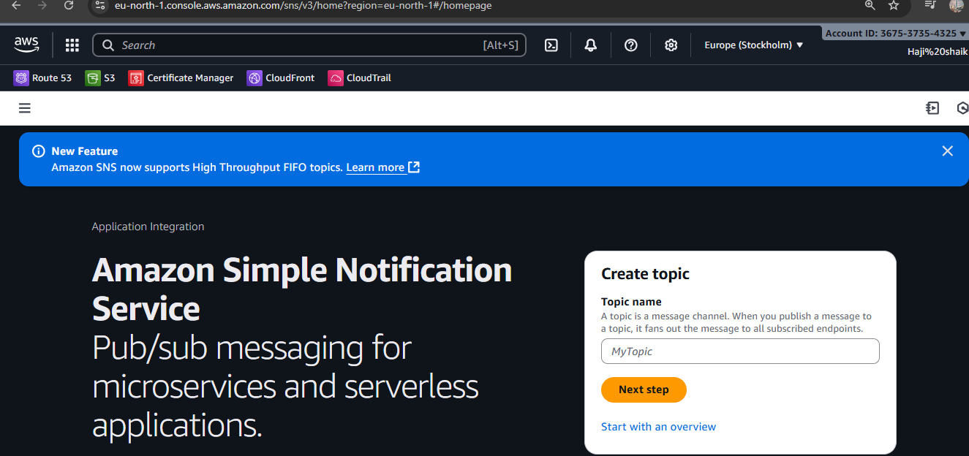

**Step-2**

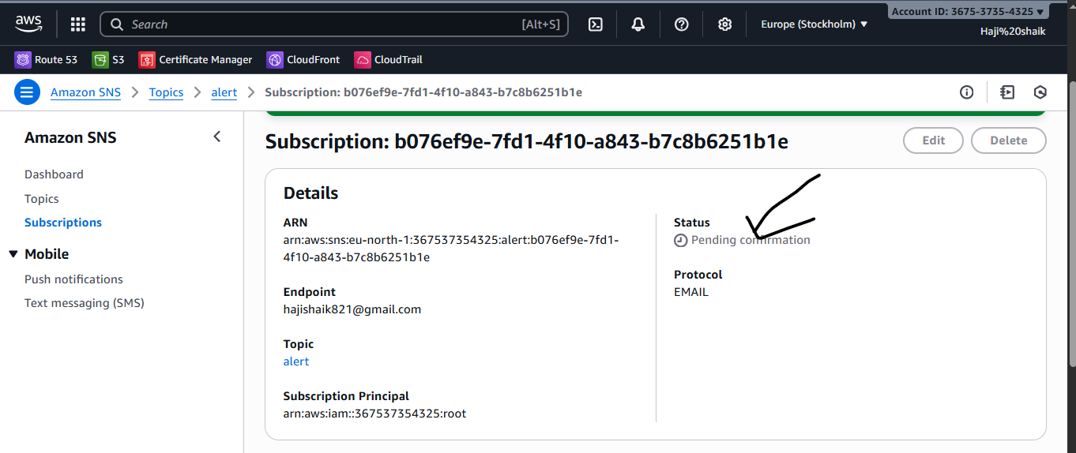

**Step-3**

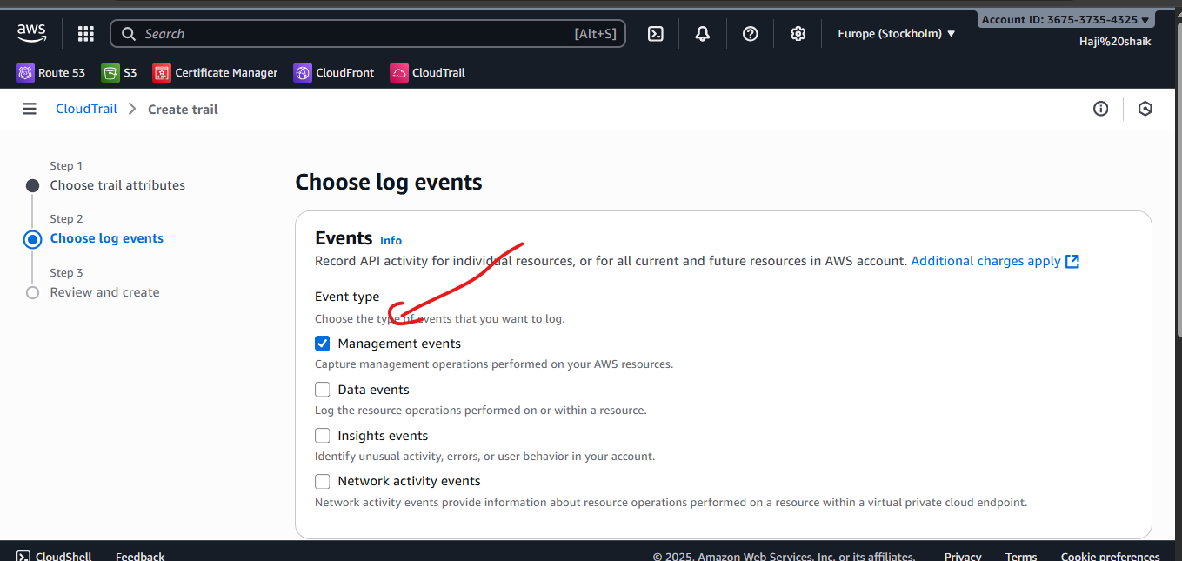

**Step-4**

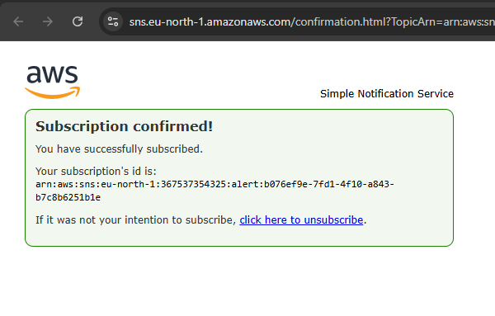

**Step-5**

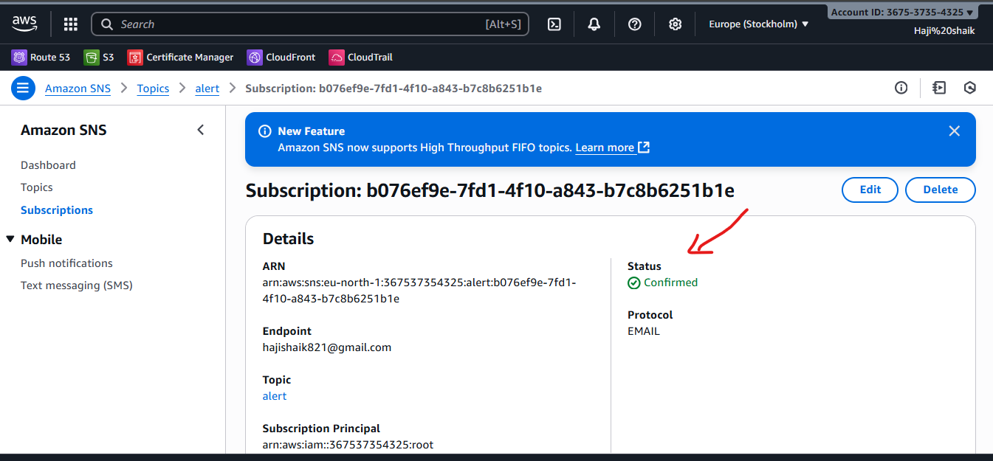

1. **Configure cloud watch monitoring and record the cpu utilization and other metrics of ec2.**

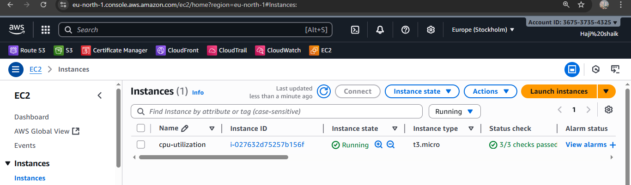

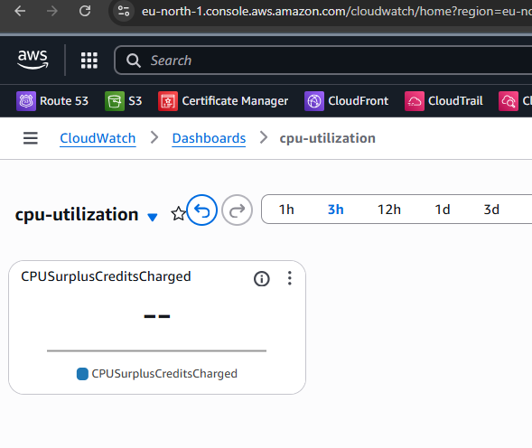

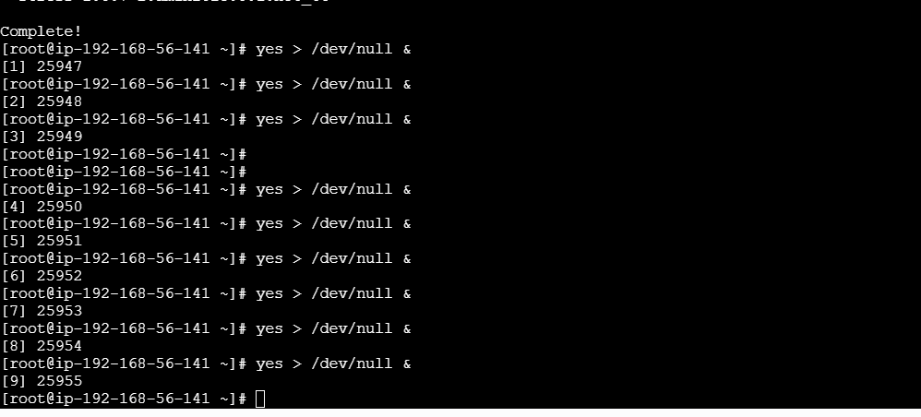

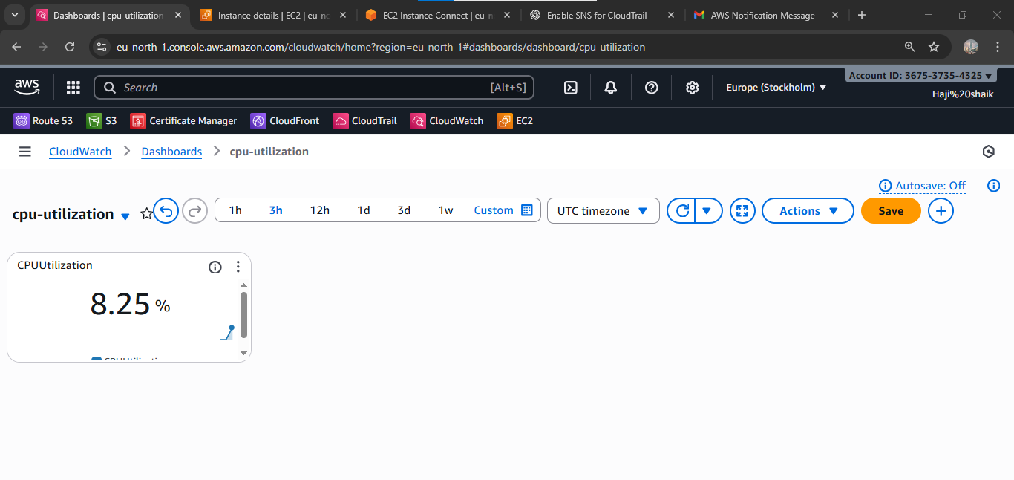

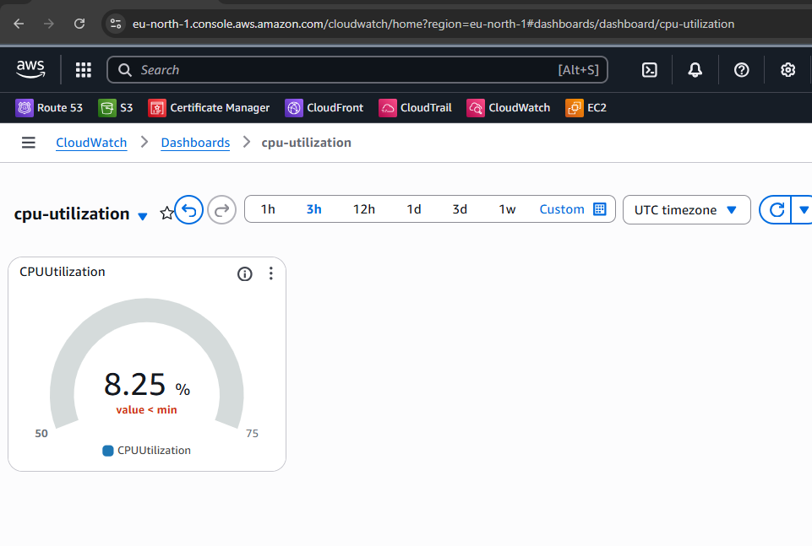

1. **Create one alarm to send alert to email if the cpu utilization is more than 70 percent.**

* **Go to Cloud watch and alarm.**
* Go to the alarm and create the alarm.
* Choose the ec2 nd preinstances and copy the instance id
* And select the instance which is related.
* **Choose a alaram type Static.**
* **Then choose greater value.**

**Here the results are:**

* 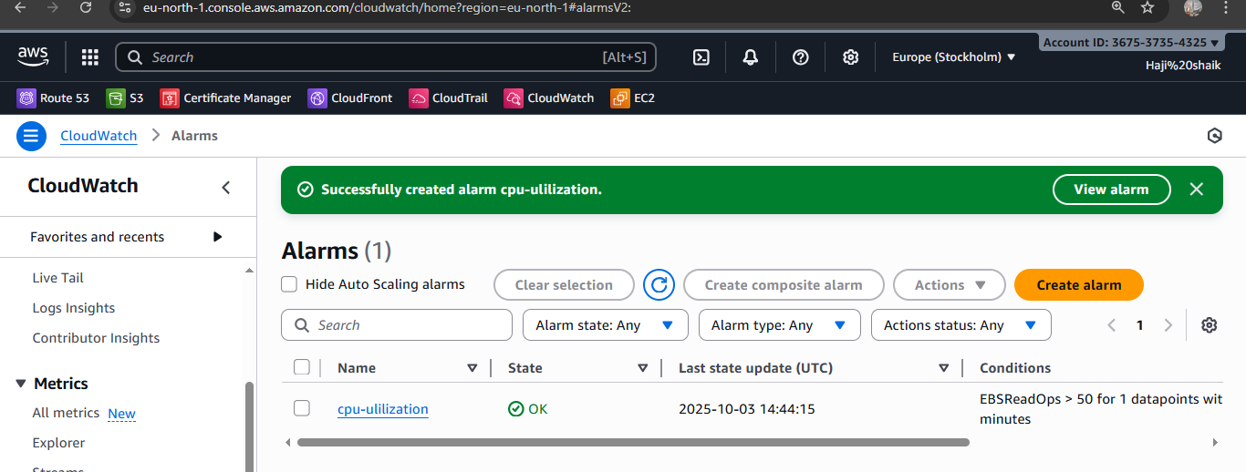

**Here the graph :**

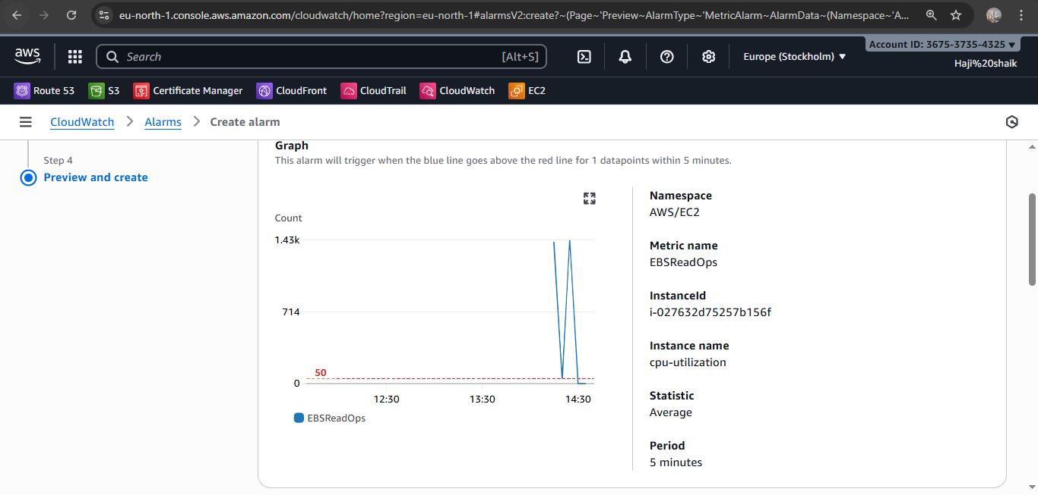

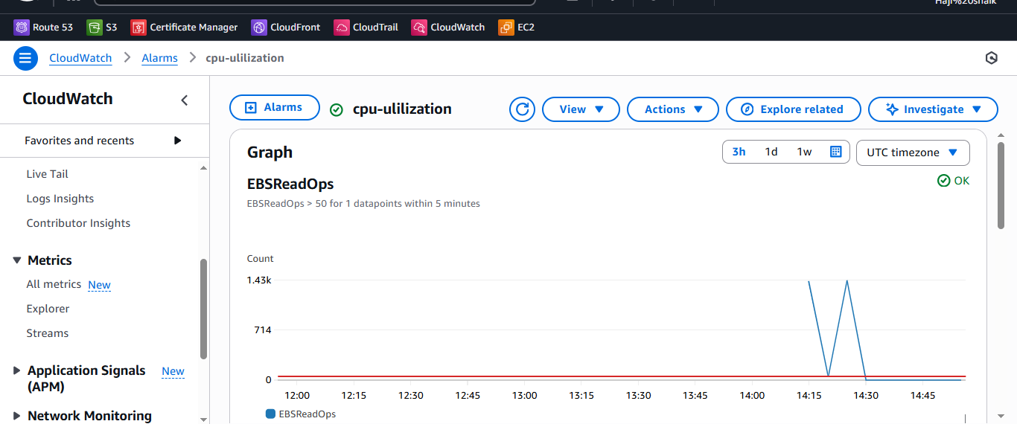

1. **Create Dashboard and monitor tomcat service wether it is running or not and send the alert.**

* yum install java-17 -y  
  ⦁ wget https://dlcdn.apache.org/tomcat/tomcat-9/v9.0.109/bin/a  
  pache-tomcat-9.0.109.tar.gz  
  ⦁ vi /opt/monitoring.sh  
  ⦁ paste these code here  
  --------------------------------------------------------------------------------------------  
  ---  
  #!/bin/bash  
  # Check if Tomcat service is active  
  if systemctl is-active --quiet tomcat; then  
  STATUS=1  
  else  
  STATUS=0
* fi  
  # Push custom metric to CloudWatch  
  aws cloudwatch put-metric-data \  
  --namespace "TomcatMonitoring" \  
  --metric-name "TomcatStatus" \  
  --value $STATUS \  
  --region eu-north-1  
  ----------------------------------------------------------------------------------------------------  
  --  
  chmod 777 monitoring.sh  
  aws configure (paste your access id and secret key)  
  crontab -e   
  paste these in crontab editor (* * * * * /opt/monitoring.sh)  
  sh monitoring.sh  
  go to aws console and go to cloud watch  
  create a dashboard---select widget---number---select tomcat-
* 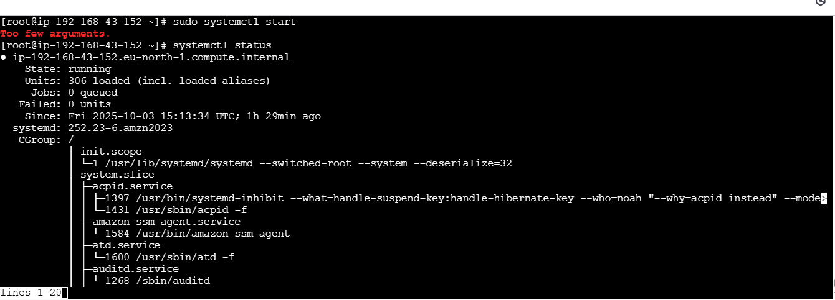

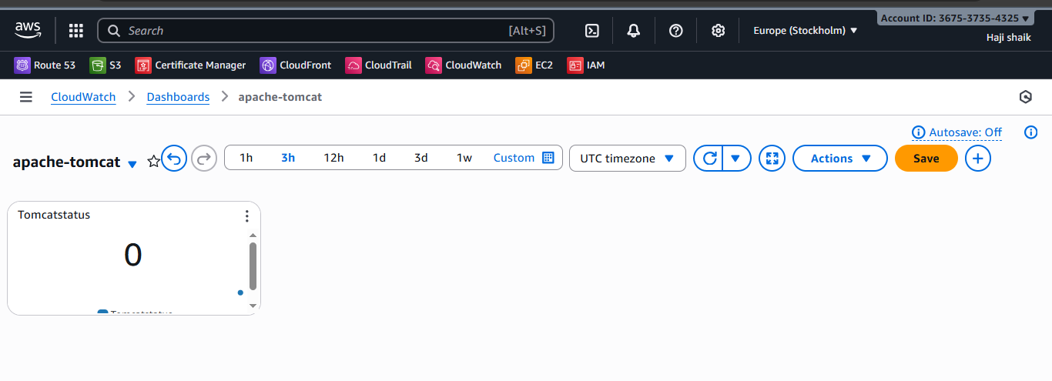

1. **Create Dashboard and monitor nginx service to send the alert if nginx is not running.**

* **C**reate a intsanse in aws console
* yum install nginx -y  
  systemctl start nginx  
  systemctl enable nginx  
  yum install cronie -y  
  systemctl start cronie  
  systemctl enable cronie  
  crontab -e   
  paste these code in cronie editor (* * * * * /home/ec2-  
  user/nginx-monitor.sh)  
  aws configure (paste your access id and secret key ) here  
  vi nginx-monitor.sh  
  ---------------------------------------------------------------------------------------  
  ---  
  #!/bin/bash  
  # Check if nginx service is active  
  if systemctl is-active --quiet nginx; then  
  STATUS=1  
  else  
  STATUS=0  
  fi

# Push custom metric to CloudWatch  
aws cloudwatch put-metric-data \  
--namespace "NginxMonitoring" \  
--metric-name "NginxStatus" \  
--value $STATUS \  
--region us-east-1  
--------------------------------------------------------------------------------------------------------------------  
----  
sh nginx-monitor.sh  
go to console and cloud watch dashboard   
add widget number  
add nginx-monitor   
create  
it will show value 1 in monitoring chart when nginx is running or   
else 0 when stopped

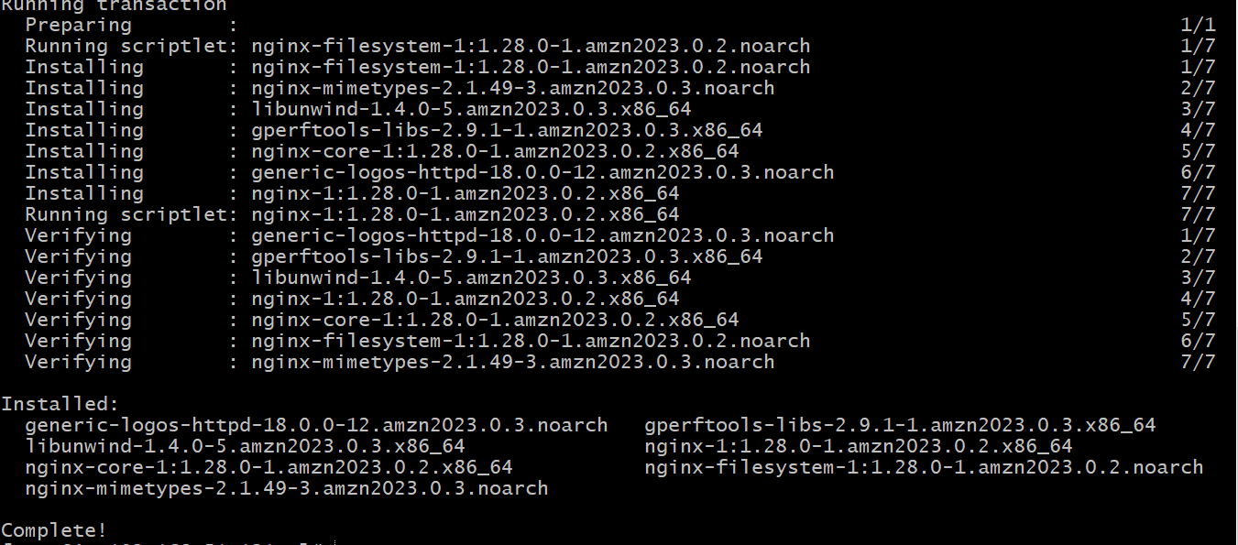

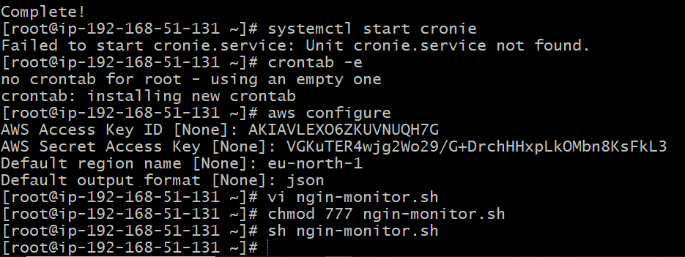

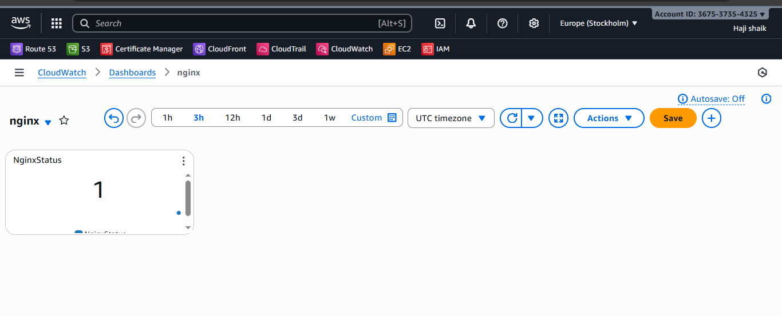

* Go to CloudWatch →Alarms →Create alarm.  
  Choose metric →NginxMonitoring →NginxStatus  
  Condition: Whenever NginxStatus < 1 for 2 datapoints within 2   
  minutes  
  Next →Create SNS Topic (Nginx-Alerts)  
  Add your email  
  Confirm subscription from your inbox  
  Save alarm